­

PROJECT

SUDOKU

SOLVER

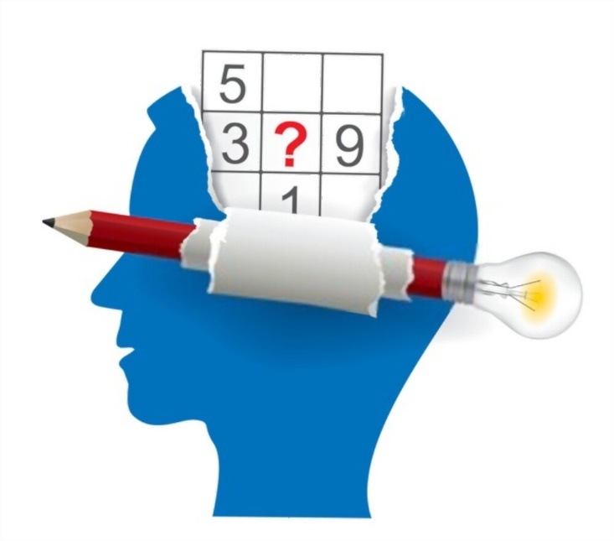

TEAM

U19CS011 RAJ JIKADRA

U19CS012 BHAGYA RANA

U19CS049 DEV JARIWALA

U19CS080 MUKTESH

Seminar Report

CS-206 DAA